Project of Functionnal Programming

Presentation of the game :

Rock Paper Scisors game play is as follow:

* There is two players, they have to choose between rock, paper and scisors
* The result of the game is either win, lose or tie from the point of view of player one such as : scisors wins over paper, paper wins over rock and rock wins over scisors.

Specifications of the types and functions used:

Types:

Gesture : Type that enumerates the possible throws (Rock, Paper and Scissors)

Result : Types represented the results of the game. Win result in a set of 2 gesture, as well as the Lose and Tie is unique gesture.

Functions:

Hand g1 g2: function that returns a result type according to the pair of gesture given.

Gesture_to_string g: identifies gesture type to the related string representation of the gesture.

Result_to_string res: identifies the result type to the related string representation of the results.

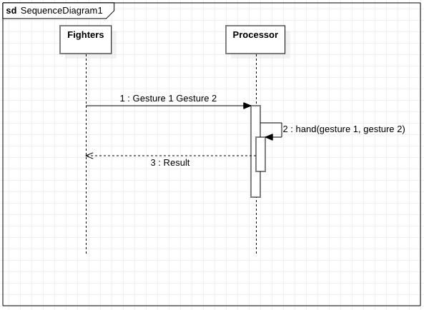

Ocaml script:

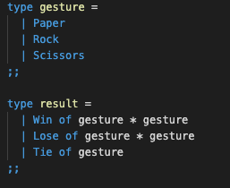

Display of the result (2 examples):

Environment of execution, compiling instructions:

Results: